J08A. GRAPHIC SERIES - Full Colour [n.l. 1902]

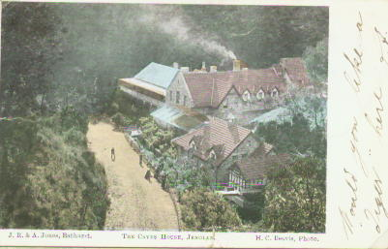

Ph H.C. Beavis (Who, with his brother, ran the Royal Studios in Bathurst in the late 19th. century. Many photographs of Jenolan by Beavis are known, and further postcards are likely to be found)
Pr Collins Bros. & Co. (see Cook 1986, p. 132)
Front of card also has various names of publishers or distributors, many of whom
were probably stationers or newsagents.

F Full-colour picture printed in halftone. Wide margin at R.H. end of card ; narrower
margin all other sides, but that at bottom contains title, photographer and the
distributor name.

J08A.1 The Caves House, Jenolan H
Publishers seen by us are:
J08A.1a J.R. & A.Jones, Bathurst (pm.27 Jun.1902)
J08A.1b L.D. Marshall, Publisher (pm 1 Apr. 1906)

J08B. GRAPHIC SERIES - single colour cards [n.l. 1907]

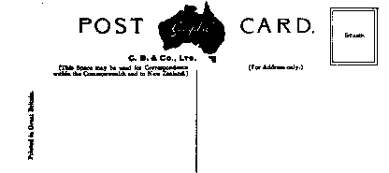

Pu Collins Bros. & Co. (Cook 1986, p. 132)
Pr In Great Britain
F Printed in bluish-green with title in lower margin.

J08B.1 The Mystery Formation, Jenolan Caves, N.S.W. H [ms.14 May 1912]
J08B.2 Grand Stalagmite, Jenolan Caves, N.S.W. V (pm.1907)

